**COMPUTER ORGANIZATION AND ARCHITECTURE LAB**

**Fall 2024, 5th Semester**

**Lab Report**



# Submitted by: **Hassan Zaib Jadoon**

Registration Number**: 22PWCSE2144**

Section: **A**

“On my honor, as a student at the University of Engineering and Technology

Peshawar, I have neither given nor received unauthorized assistance on this academic work.”

**Submitted To: Dr. Amad Khalil**   
**Department of Computer Systems Engineering**  
**University of Engineering and Technology Peshawar**

**Objective:**

To understand the basic concepts of computer organization and architecture, the differences between CISC and RISC architectures, and the use of MIPS architecture with QtSPIM simulator.

### **1. Introduction to Computer Organization and Architecture**

**Computer Organization:**  
Refers to the physical and logical arrangement of a computer’s hardware. It deals with the actual operational units, the interconnections between hardware components, and the implementation of architecture specifications.

**Examples** include:

* Control signals
* RAM size
* Input/Output (I/O) devices
* Timer
* Interrupts

**Computer Architecture:**  
Refers to the behavior and structure of a computer as seen by a programmer. It focuses on the design of the system's functionality, including how the CPU and memory work together. From the programmer's perspective, computer architecture defines what the computer does.

**Examples** include:

* Instruction set design
* Memory addressing
* Instruction execution
* CPU functionality

In simple terms:

* **Computer architecture** defines *what* a computer does.
* **Computer organization** explains *how* it does it.

**2. Types of Computer Architectures**

**CISC (Complex Instruction Set Computing):** CISC provides a large set of instructions, allowing the processor to perform complex operations within a single instruction. The goal of CISC is to reduce the number of instructions per program by making each instruction more capable.

* Instructions are complex and can perform multiple operations.
* Instruction length is variable.
* CISC is harder to pipeline due to its complexity.

**RISC (Reduced Instruction Set Computing):**

RISC simplifies the instruction set, ensuring each instruction takes only one clock cycle. This leads to faster execution and easier pipelining.

* Instructions are simpler and faster.
* Fixed-length instructions.
* Each instruction is executed in a single clock cycle, making it highly optimized for pipelining.

|  |  |  |
| --- | --- | --- |
| Feature | RISC | CISC |
| Instruction Complexity | Fewer, simpler instructions | Many complex instructions |
| Instruction Length | Fixed | Variable |
| Clock Cycles per Instruction | Single clock cycle | Multiple clock cycles |
| Memory Access | Load/store architecture | Direct memory access with most instructions |
| Pipelining | Highly optimized | More difficult due to complexity |
| Hardware Design | Simple, fewer transistors | Complex design |
| Examples | MIPS, ARM, PowerPC | Intel, AMD |

Table 1: Features of RISC & CISC

**3. MIPS Architecture**

**MIPS** stands for *Microprocessor without Interlocked Pipeline Stages*, and it follows the RISC design principles. It was developed in the early 1980s and is known for its simplicity, efficiency, and pipeline design. MIPS processors are widely used in embedded systems and high-performance applications.

* **Fixed-length instructions**: Instructions in MIPS have the same length, making it easier to predict and optimize.
* **Efficiency**: MIPS focuses on simplicity, enabling faster execution and efficient pipelining.

**4. QtSPIM Simulator**

**QtSPIM** is a simulator that allows users to run MIPS assembly language programs. It simulates the operations of a MIPS processor, providing a learning platform for students to understand MIPS architecture.

**Key Points:**

1. **Simulates MIPS Processor**: Helps in understanding the workings of a MIPS-based system.
2. **Runs Assembly Code**: Users can write and execute MIPS assembly language programs.
3. **Registers and Memory**: Shows how data is stored in registers and memory.
4. **Simple Interface**: Allows users to load, run, and step through programs easily.
5. **Helps in Debugging**: Helps find and fix errors by observing changes in registers and memory.

**5. QtSPIM File Structure**

**Source File Name**:  
The source file name where MIPS assembly code is written usually ends with .asm or .s. This file is loaded into QtSPIM for execution.

**Memory Segments in QtSPIM**:

* **Text Segment**: Contains the instructions of the program (e.g., addiu, lw, syscall).
* 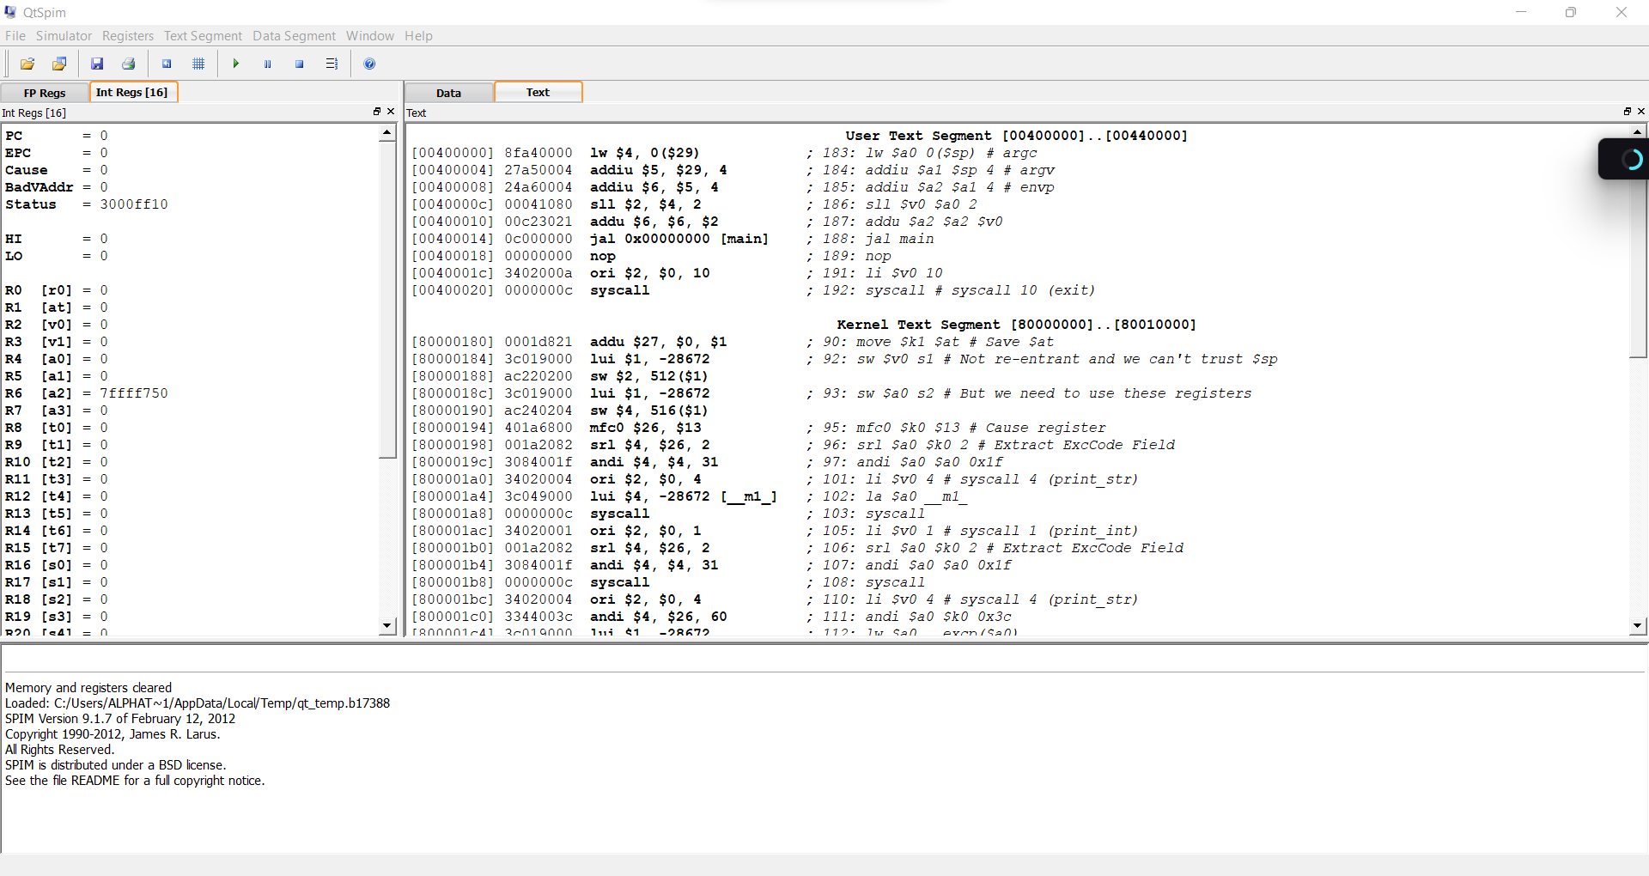**Data Segment**: Stores the program’s data, such as variables and constants. It holds the static/global variables and memory used during the execution of the program.

Figure : QTSPIM Structure

**Part II**

Write a program in MIPS assembly language, task2.asm, that computes and prints the sum of two numbers specified at runtime by the user. The program uses registers $t0 and $t1 to store the two user inputs, while $t2 holds the computed sum of these two values. It utilizes the $v0 register for system call numbers and $a0 for passing arguments to system calls. Upon execution, the program prompts the user to enter two integers, calculates their sum, and displays the result on the console before terminating gracefully. This program effectively demonstrates basic input, arithmetic operations, and output handling in MIPS assembly language.

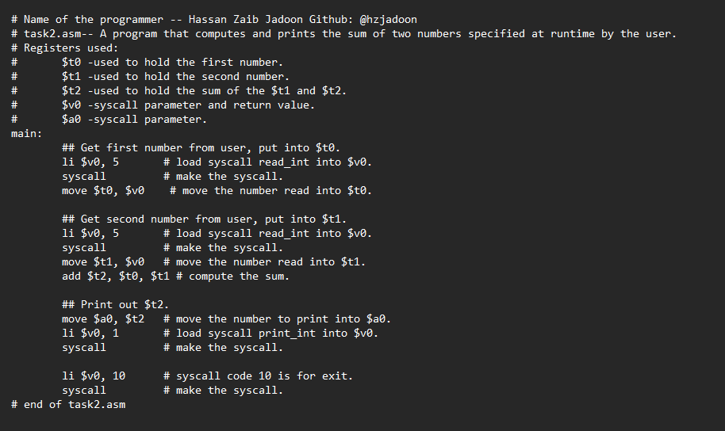

**Output:**

**System calls:**

Through the system call (syscall) instruction, SPIM offers a limited number of operating system-like services. A program loads the arguments into registers $a0,….$a3 (or $f12 for floating point values) and the system call code into register $v0 in order to request a service. Values returned by system calls are stored in register $v0 (or $f0 for floating point results). To print "the answer = 5," for instance

Task 3:

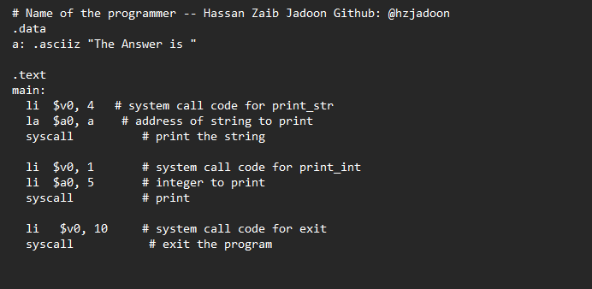

Output:

